**Mr GREEN HOME ASSISTANT**

**Circuit diagram:**

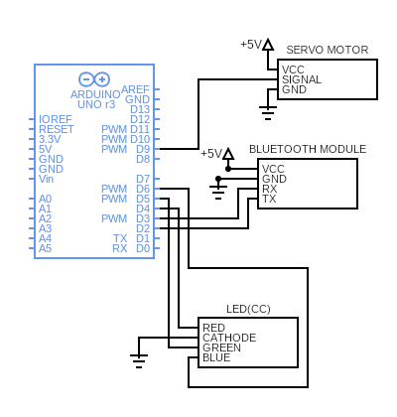

**Working of components**

**Arduino UNO Board:**

The user can get started by connecting the Uno to a computer with the USB cable or by powering it with an AC / DC adapter or battery. The Uno can be programmed with Arduino Software (Integrated Development Environment). Arduino Uno features 14 digital input /output pins (six of which can be used as PWM outputs), six analog inputs, and a16MHz quartz crystal. Uno also includes a USB connection, a power jack, an In-Circuit Serial Programming (ICSP) header, and a reset button. This Arduino MCU board contains everything the user needs to support the MCU.

**HC-05 Bluetooth Module:**

The Bluetooth standard, like WiFi, uses the FHSS technique (Frequency-Hopping Spread Spectrum), which involves splitting the frequency band of 2.402-2.480 GHz into 79 channels (called hops), each 1MHz wide. Then it transmits the signal using a sequence of channels known to both the sending and receiving stations. Thus, by switching channels as often as 1600 times a second, the Bluetooth standard can avoid interference with other radio signals.

The Bluetooth standard is based upon a master/slave operational mode. The term piconet is used to refer to the network formed by one device and all devices found within its range. Up to 10 piconets can coexist within a single coverage area. A master can simultaneously connect to up to 7 active slave devices (255 when in parked mode). Devices in a piconet have a logical address of 3 bits, for a maximum of 8 devices. Devices in parked mode are synchronized, but do not have their own physical address in the piconet. In reality, at a given moment, the master device can only be connected to a single slave at once. Therefore, it quickly switches between slaves in order to make it seem as if it is simultaneously connected to all the slave devices. Bluetooth enables two piconets to be linked to one another in order to form a wider network, called a scatternet, using certain devices which act as a bridge between the two piconets.

HC-05 Bluetooth Module is an easy-to-use Bluetooth SPP (Serial Port Protocol) module, designed for transparent wireless serial connection setup. Its communication is via serial communication which makes an easy way to interface with controller or PC.

**Servo Motor:**

The servo motor is connected to the D8 pin of Arduino. A servo consists of a Motor (DC or AC), a potentiometer, gear assembly, and a controlling circuit. First of all, we use gear assembly to reduce RPM and to increase torque of the motor. Say at initial position of servo motor shaft, the position of the potentiometer knob is such that there is no electrical signal generated at the output port of the potentiometer. Now an electrical signal is given to another input terminal of the error detector amplifier. Now the difference between these two signals, one comes from the potentiometer and another comes from other sources, will be processed in a feedback mechanism and output will be provided in terms of error signal. This error signal acts as the input for motor and motor starts rotating. Now motor shaft is connected with the potentiometer and as the motor rotates so the potentiometer and it will generate a signal. So as the potentiometer’s angular position changes, its output feedback signal changes. After sometime the position of potentiometer reaches at a position that the output of potentiometer is same as external signal provided. At this condition, there will be no output signal from the amplifier to the motor input as there is no difference between external applied signal and the signal generated at potentiometer, and in this situation motor stops rotating.

**Common Cathode LED:**

Common cathode means that the cathodes of all of the LEDs are common and connected to a single pin. The anode for each LED has its own pin. So, driving one of these means running a current from the particular anode (positive) pin for the desired segment to the common cathode pin.

In a common cathode RGB LED, the cathode of the internal LEDs are all connected to the external cathode lead as mentioned earlier. To control each colour, you need to apply a HIGH signal or VCC to the red, green, and blue leads and connect the anode lead to the negative terminal of the power supply.